Appendix 1: Elements of Ethiopia’s existing social protection strategy
Protect Humanitarian emergency program. (2.7 million People per year).
Productive safety net program (8million):
Prevent 30,000 salaried health extension workers providing a package of 16
free services.
Promote Micro credit (small).
Resettlement Program (small).
Fertilizer subsidies
Getting the last 3 million children into school (feeding, ABE center,
mobile school)
Vocational skills training for youth (small).
Disability support actions (small).
Social insurance (civil servants only)

Appendix 2 – Questions for beneficiaries /Vulnerable elders/

Date____________

Time __________

A. Demographic information

Name __________________________ Code _____________________

1. Sex Male

Female

2. Age _______________

3. Religion ______________

4. Ethnicity ______________

5. Economical Status Self-sufficient Dependent
6. Dependents None Dependents

7. From where did you come? (Location and Region)__________________

8. Marital Status__________________

9. Birth place___________________

B. Experience in the association

1. When did you come here? How long you have been treated /hospitalized in the association?

2. Why did you come to this association? What makes you to come here?

3. What is the process to be admitted here? How do you get here?

4. What is your belief and attitude about the care and support services? What does it mean to you?

5. Do you believe the services rendered are enough?

Yes No don’t know

Other _______________________________

6. What are the services that you are obtaining from this association? Please describe the
Things that you are getting?

7. What resources /support (manpower and other) can you identify from the association and the
surrounding?

8. What are your problems or needs (basic and other) that are not addressed? Or what
problems do you see here?

9. What do you think are the causes of the problems?

10. Were there any interventions made to mitigate the problems?

11. What do you think are the solutions?

13. What is your future plan? How long will you stay here (treat yourself) with holy

Appendix 3- Questions for Caregivers

Name ________________

Age __________________

Sex__________________

Length of time as Caregiver_______________________

On what basis: Church servant Volunteer family

Part of organization Paid

Other__________________________

1. What are your activities (deeds) here within the association?

2. How and why do you get into these activities?

3. What problems and needs you observed on the beneficiaries?

4. What problems and challenges you faced so far while providing the care and
support?

5. What should be done to alleviate the problems?

6. Do you feel you have the capacity to provide care and support? Explain?

7. What is your future plan regarding this care and support?

Appendix 4- Questions for Key Informants /Stake holders/

Name ________________________

Position ______________________

General: - Historical information

1. What types of targets are coming here?

2. What kinds of care and support activities are made for them?

3. Who are involving in the care and support activities (i.e. priests, care givers and others)?

4. What are the need and problems of the targets?

5. What problems do you face while trying to give care and support to the targets?

6. Were there any interventions made by external regulatory bodies?

7. What are your plans in the care and support activity?

8. How is the process of admission and registration at the association? Please explain?

9. Explain about the documentation system?

10. What is the trend in the number and demographic characteristics of people coming to
the place?

Appendix-5- Spatial and temporal description of the interviews
No | Informants code | Date of interview | Time | Venue
1 | TB1-F | 24 Dec; 2011 | 12: 40 Am - 1:30 PM | Cafeteria
2 | TB2-M | 16 Jan; 2012 | 4:25pm-5: 35 Pm | Churchyard
3 | TB3-M | 16 Jan; 2012 | 5:55-pm –6:55Pm | Churchyard
4 | TB4-F | 18 Jan; 2012 | 2:25-Pm - 9: 35Pm | Shelter home
5 | CG1-F | 20 Jan; 2012 | 5:20Pm-6: 20 Pm | Church yard
6 | TB5-F | 6 Jan; 2012 | 4:30Pm-5: 50Pm | Holy water site
7 | TB6-F | 7 Jan; 2012 | 4:30Pm-5: 30Pm | Holy water site
8 | TB7-M | 8 Jan ; 2012 | 4:15Pm-5: 25Pm | Holy water site
9 | TB8-F | 10 Jan; 2012 | 4:40Pm-6:00Pm | Church yard
10 | TB17-F | 10 Jan; 2012 | 9:00Am-9: 45Am | Home
11 | TB16-F | 10 Jan; 2012 | 9:50Am-10: 50 Am | Home
12 | SHM-1 | 10 Jan ; 2012 | 11:00Am-11: 45Am | Churchyard
13 | TB15-F | 14 Jan; 2012 | 9:25Am-10: 10AM | Holy water site
14 | CG2-M | 7 Jan; 2012 | 10:35 AM-11: 20Am | Shelter Home
15 | CG3-F | 20 Jan; 2012 | 12:15Am-1: 15Pm | Her home
16 | TB9-M | 21 Jan; 2012 | 9:30Am-10: 20Am | Shelter Home
17 | TB10-F | 21 Jan; 2012 | 10:45Am-11: 25Am | Churchyard
18 | SHF-2 | 18 Jan; 2012 | 4:15Pm-5: 15PM | On the field
19 | SHM-3 | 21 Jan; 2012 | 5:25Pm-6: 25Pm | Home
20 | SHM-4 | 23 Jan; 2012 | 2:30Pm-3: 20Pm | On the field
21 | SHM-5 | 3 Feb; 2012 | 10:55Am-11: 55AM | Churchyard
22 | CGM-4 | 20 Jan; 2012 | 11:25Am-11: 55AM | On he field
23 | CGM-5 | 31 Jan; 2012 | 1:10Pm-3:00PM | Churchyard  and office
24 | SHM-6 | 31 Jan; 2012 | 9:50Am-10: 35Am | Office
25 | TB11-M | 31 Jan; 2012 | 9:55Am-10: 30 Am | Churchyard
26 | TB12-F | 30 Jan; 2012 | 10:30Am-5: 50 AM | Office
27 | TB13-F | 22 Jan; 2012 | 2:10Pm-2: 35 Pm | Office
28 | TB14-M | 20 Feb; 2012 | 12:10Am-1: 35Pm | Office

Appendix –6- Consent form

A consent form

Prepared for target beneficiaries and caregivers

I, who put my signature below, fully agree to be part of the research of Yidnekachew Fekadu by giving information through interview.
Name _______________________
Signature _________________________
Date ______________________________

Appendix –7- Photographs

7.1 The front view of ‘Entoto Kidanemiheret’ Church.
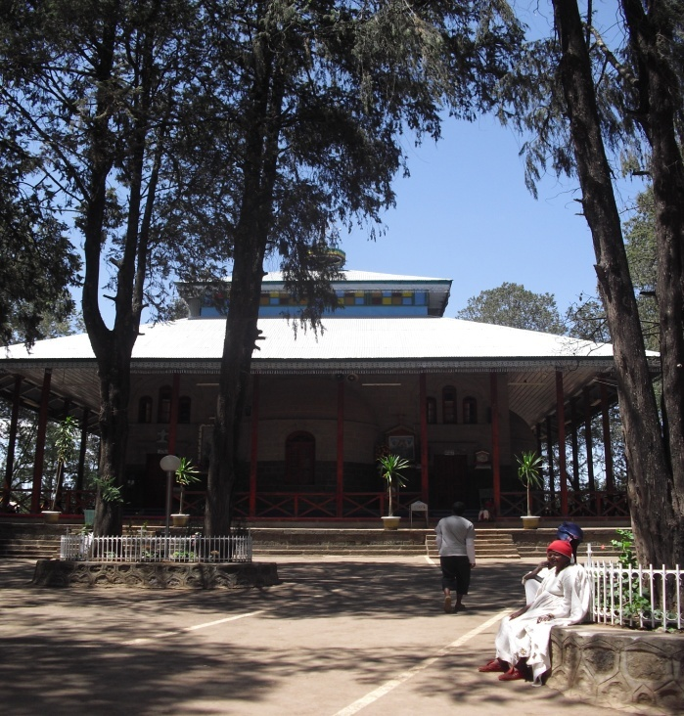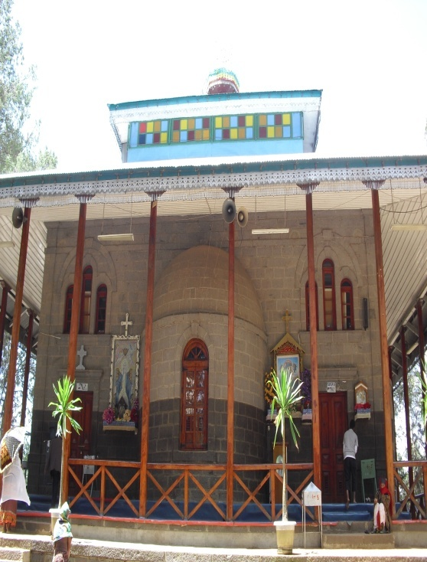
The church was established in 492 A.D. with the aim of spreading Orthodox Christianity in the area. Its long standing history of preaching the good deeds towards the needy makes it a residing area for most particularly the elderly.
7.2. The side view of ‘Entoto Kidanemiheret’ Church.

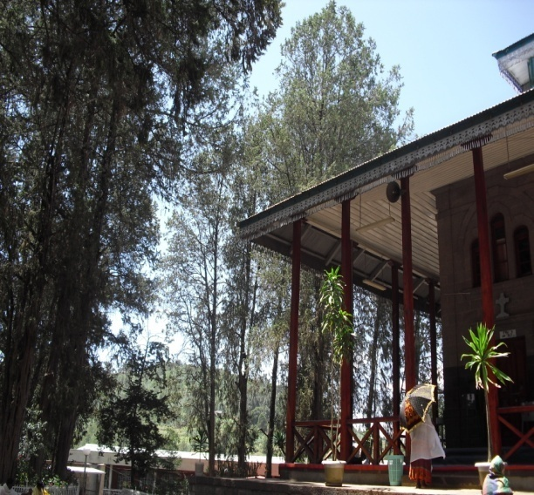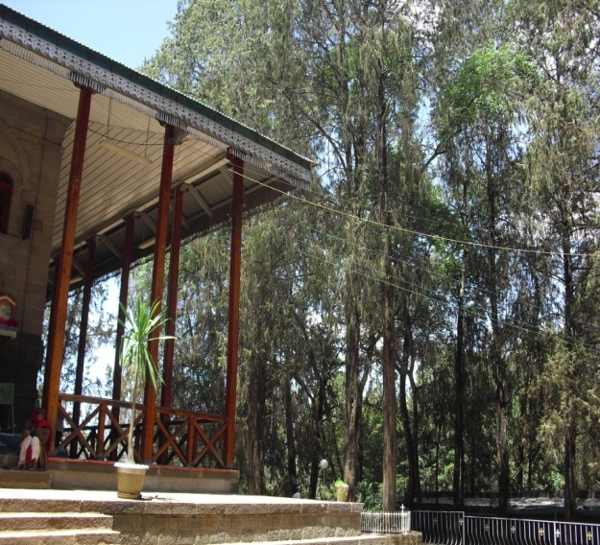
7.3. The front gate and administrative building of ‘Entoto Kidanemiheret’ Monastery.

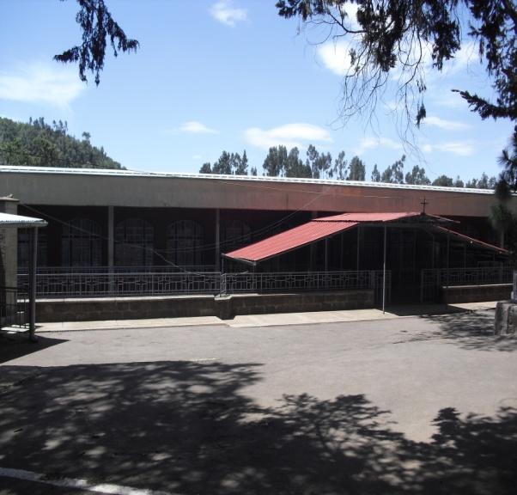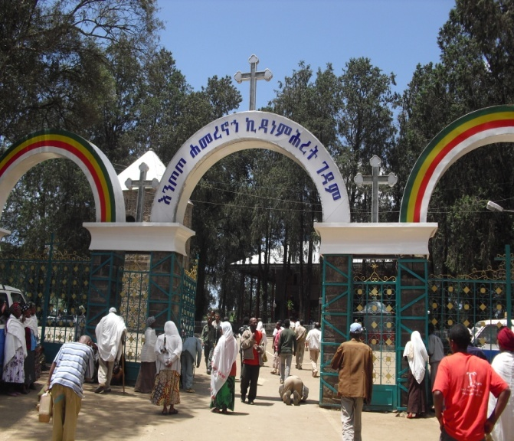
The monastery was established a few years later, after the church, in 508 A.D. and has been conducting various developmental activities including building spiritual school, rendering holy water services and assists the community in any developmental endeavor while employing its member gathering as a means for resources.
7.4. The holy water site of the monastery.
[
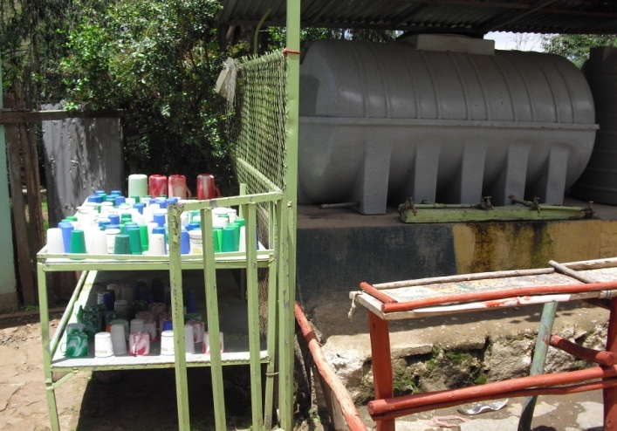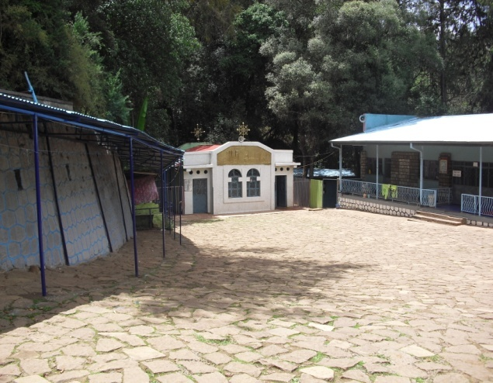
This is the place where the beneficiaries (i.e. the elderly) of the association get the service either through shower or drinking.
7.5. The surrounding environment where the association established.

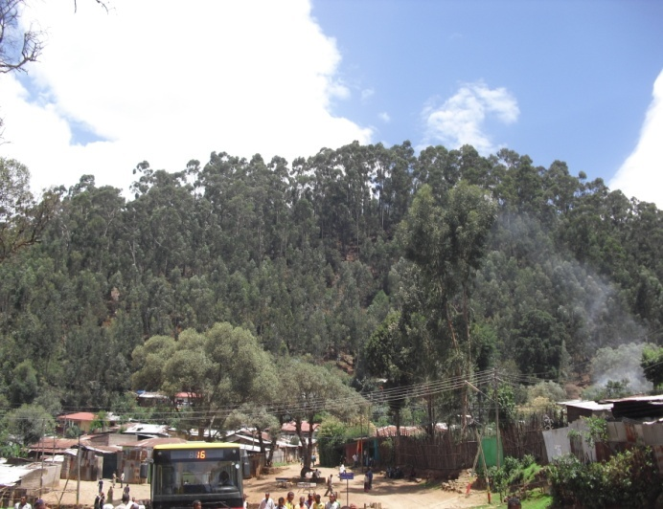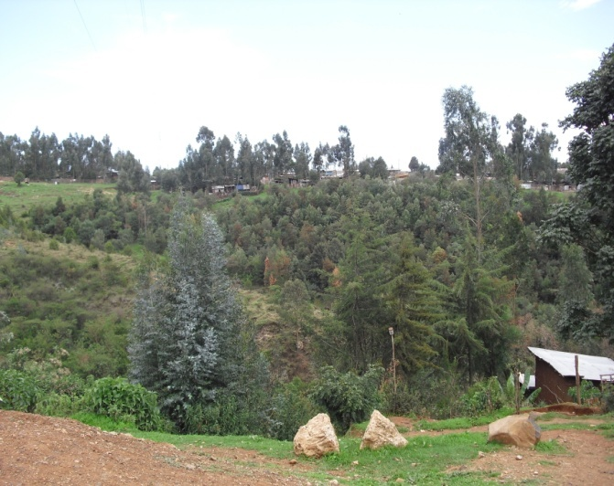
The surrounding environment where both the monastery and ‘Yewedekuten Ansu’ association situated is covered with vegetation.
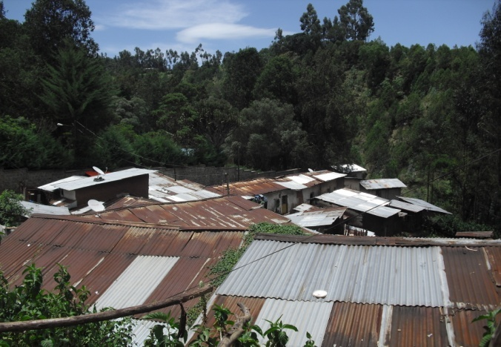
7.6. The location of ‘Yewedekuten Ansu’ Association
The association was established in 1998G.C. and has been benefited a total of 420 vulnerable elders out of which 65 of them are under the custody of the association recently.

The association is situated in congested area where it conduct the activity in four shelter homes, out of which the first two were rented from the Kebele while the other two from individuals..Members and supporters of the association rendered their assistance in different ways:
- Through medical treatment
- Project design
- Consultancy and guidance
- And through advocacy and awareness creation campaigns as to motivating the community at large towards consistent support.

The table is quoted from People at Risk: Towards a Comprehensive Social Protection Scheme in Ethiopia, 2011
‘Yehamere nohe Kidanemiheret' monastery developmental plan bulletin, 1992.
‘Yehamere nohe Kidanemiheret' monastery developmental plan bulletin, 1992.
Since photographing is strictly forbidden, I only managed to capture the upper view of the shelter homes of the association among other residences of the area.
The lowest governmental administrative system.

